**Data Analysis of McDonald's Burger Sales**

## Micro Trends from Daily Granularity

#### Insight

The line chart above displays the total sales of all burgers together for each day of week (from Monday to Sunday). We can see that the sales of burger is relatively lower during weekends. Since McDonald is a fast food company, it is reasonable that our customer prefer to come during weekdays when they are too busy to squeeze time for dinner. During weekends, they would have many other alternatives for their leisure time.

#### Solution

This phenomenon is determined by the nature of McDonald’s. However, to increase the sales of those three burgers at McDonald’s during weekends, we can introduce several nutritious and sumptuous meal plan with those burgers as a choice only for weekends. This way, customers would raise their interests in McDonald’s during weekends.

## Overall Distribution of Burger Sales in Different Regions

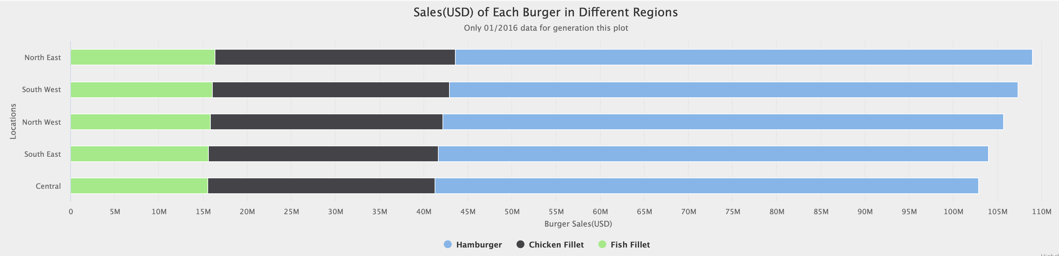

#### Insight

The bar plot displays the sales of each burger in all five different regions. Based on the information in the chart, all five regions have an almost equal distribution of all three kinds of burger. And the total sales of burger in all five regions are fairly equal. This phenomenon indicates that there is no huge differences between the popularity of each burger over all five regions. Thus, we are relaxed to deploy the same business strategy to all five regions.

## Influence of the Impossible Burger

#### Insight

The line chart above describes overall burger sales over the past three years (from 01/2016 to 09/2019). Before the introduction of “the Impossible Burger” in 10/2018, the sales at McDonald’s increase steadily. However, there is a clear drop between 09/2018 and 10/2018. Thus, the introduction of “the Impossible Burger” by Burger King definitely encroaches McDonald’s market share.

#### Insight

By looking deeper into the effect of “the Impossible Burger” on the sales of each burger at McDonald’s, it is clear that the proportion of sales drop for each burger (Hamburger, Fish Fillet and Chicken Fillet) are approximately the same. This phenomenon indicates that there is an equal proportion of customers switches to “the Impossible Burger” from the three kinds of burger at McDonald’s.

#### Insight

If we switch to the perspective of sales pattern in each region, we still find that the sales drop of all three burgers sum up altogether are approximately equal in different regions. This phenomenon indicates that the influence of “the Impossible Burger” are insensitive to regions.

#### Solution

Based on the insight above, the conclusion can be made that the attraction of “the Impossible Burger” to McDonald’s customers are insensitive to both burger kinds and regions. Thus, market vacancy for a Veggie burger (“the Impossible Burger” is a Veggie burger) definitely exists and McDonald’s should take action in response to it. Thus, it is highly recommended that McDonald’s also launches a kind of Veggie burger to compete against “the Impossible Burger”. And the strategy can be deployed across the nation since the effect of “the Impossible Burger” are equal across the nation.